1. **Create a Spring Web Project using Maven**

**Application.java**

package org.example.ex1;

import org.slf4j.Logger;

import org.slf4j.LoggerFactory;

import org.springframework.boot.SpringApplication;

import org.springframework.boot.autoconfigure.SpringBootApplication;

@SpringBootApplication

public class Ex1Application {

private static final Logger LOGGER = LoggerFactory.getLogger(Ex1Application.class);

public static void main(String[] args) {

SpringApplication.run(Ex1Application.class, args);

System.out.println("This is a simple web project created in maven");

LOGGER.info("Inside main method");

}

}

package org.example;

import org.springframework.context.ApplicationContext;

import org.springframework.context.support.ClassPathXmlApplicationContext;

import java.text.SimpleDateFormat;

import java.util.Date;

public class App

{

public static void main ( String[] args )throws Exception

{

ApplicationContext context= new ClassPathXmlApplicationContext("data-format.xml");

SimpleDateFormat format=context.getBean("dateFormat", SimpleDateFormat.class);

Date date= format.parse("31/08/2024");

System.out.println(date);

}

}

Output:

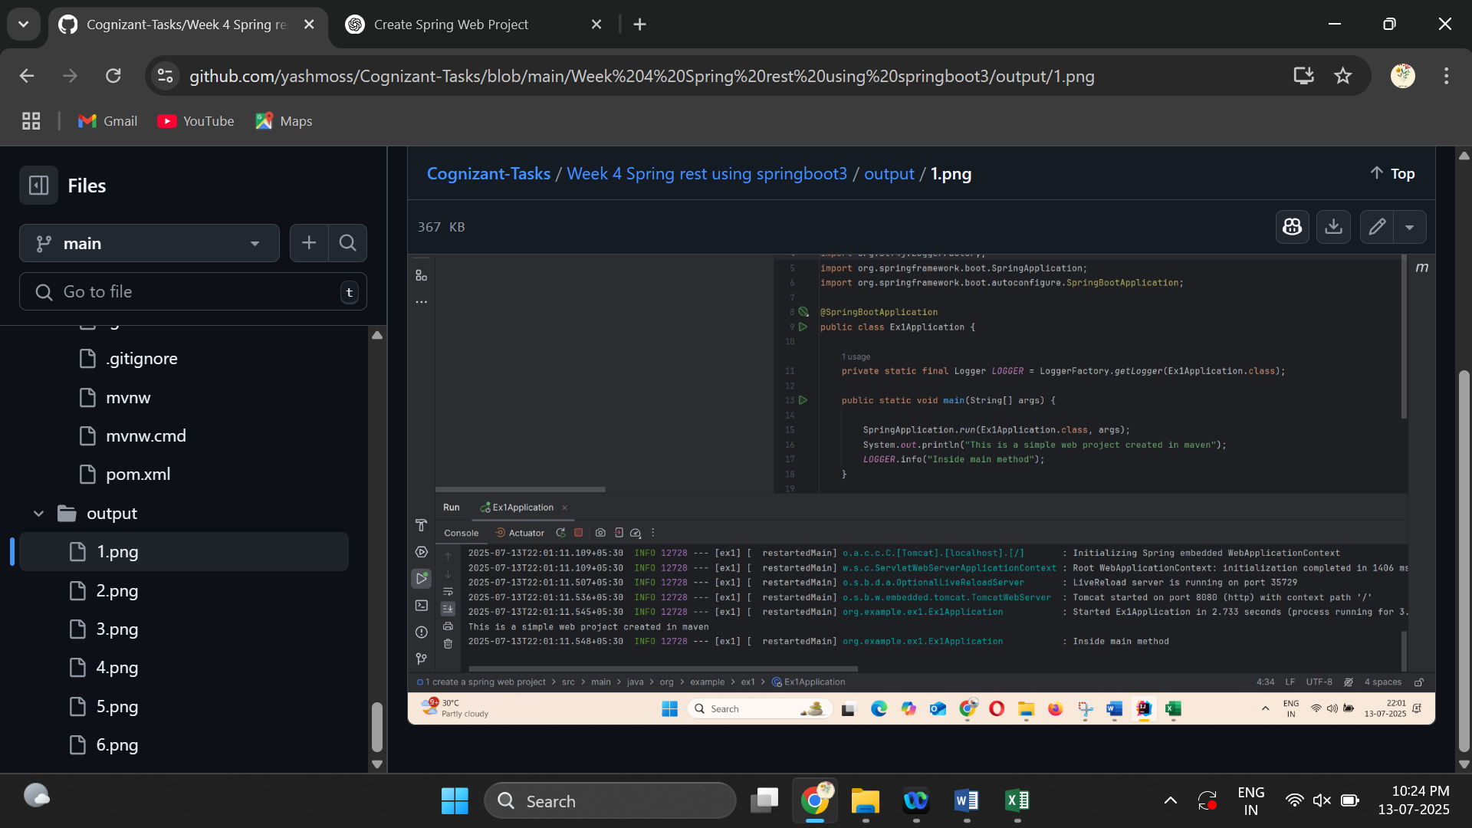

1. **Spring Core – Load Country from Spring Configuration XML**

package org.example;

import junit.framework.Test;

import junit.framework.TestCase;

import junit.framework.TestSuite;

/**

* Unit test for simple App.

*/

public class AppTest

extends TestCase

{

/**

* Create the test case

*

* @param testName name of the test case

*/

public AppTest( String testName )

{

super( testName );

}

/**

* @return the suite of tests being tested

*/

public static Test suite()

{

return new TestSuite( AppTest.class );

}

/**

* Rigourous Test :-)

*/

public void testApp()

{

assertTrue( true );

}

}

Output:

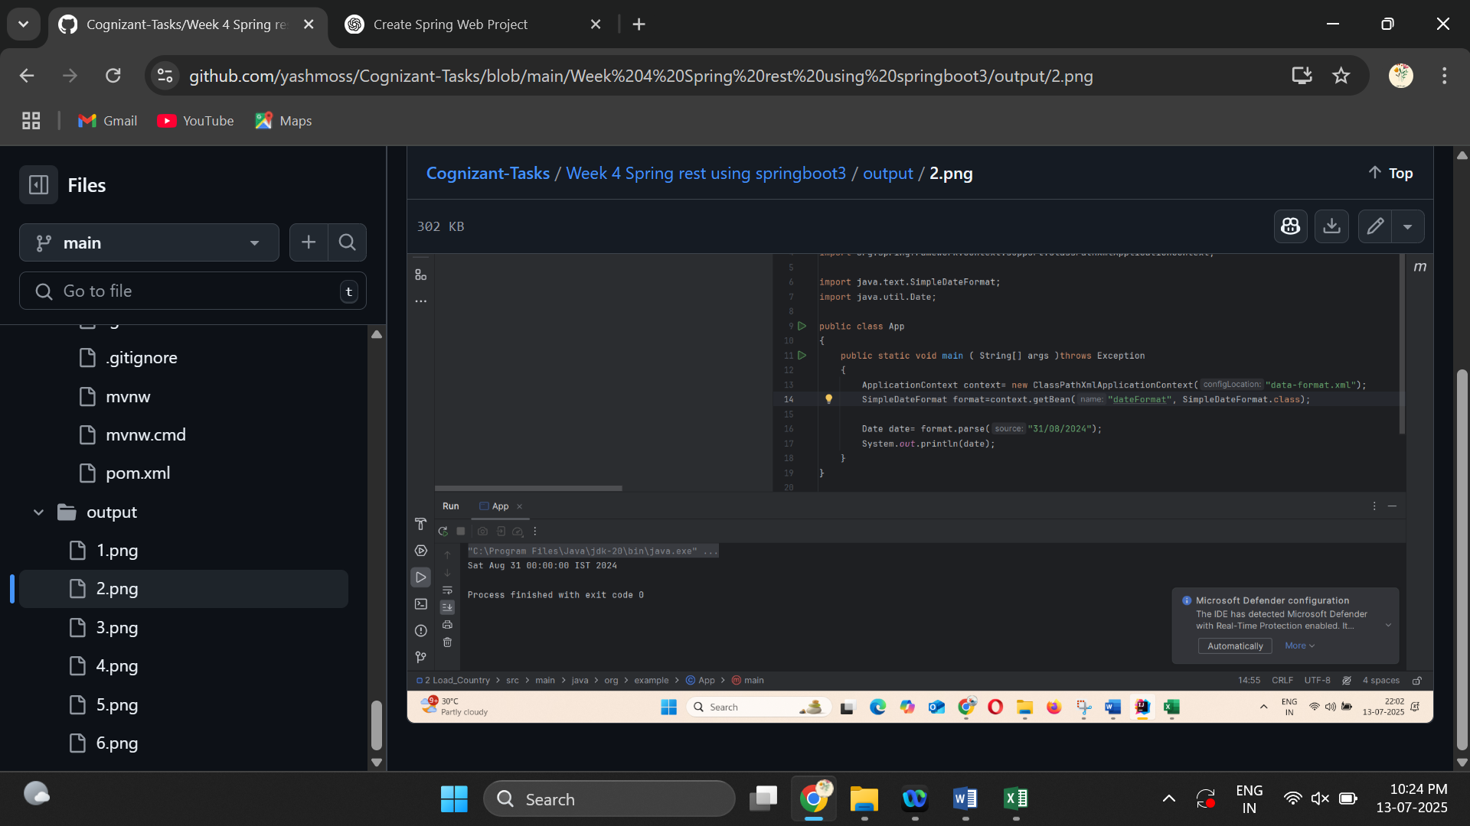

1. **Hello World RESTful Web Service**

**Controller <- package**  
package org.example.springrest_helloworld.controller;

import org.slf4j.Logger;

import org.slf4j.LoggerFactory;

import org.springframework.web.bind.annotation.GetMapping;

import org.springframework.web.bind.annotation.RestController;

@RestController

public class HelloController {

public static final Logger logger= LoggerFactory.getLogger(HelloController.class);

@GetMapping("/hello")

public String hello(){

logger.info("Started hello()");

String message="Hello World!";

logger.info("Ended hello()");

return message;

}

}

**HelloController .java**

package org.example.springrest_helloworld.controller;

import org.slf4j.Logger;

import org.slf4j.LoggerFactory;

import org.springframework.web.bind.annotation.GetMapping;

import org.springframework.web.bind.annotation.RestController;

@RestController

public class HelloController {

public static final Logger logger= LoggerFactory.getLogger(HelloController.class);

@GetMapping("/hello")

public String hello(){

logger.info("Started hello()");

String message="Hello World!";

logger.info("Ended hello()");

return message;

}

}

**SpringrestHelloworldApplication.java**

package org.example.springrest_helloworld;

import org.springframework.boot.SpringApplication;

import org.springframework.boot.autoconfigure.SpringBootApplication;

@SpringBootApplication

public class SpringrestHelloworldApplication {

public static void main(String[] args) {

SpringApplication.run(SpringrestHelloworldApplication.class, args);

}

}

Output:

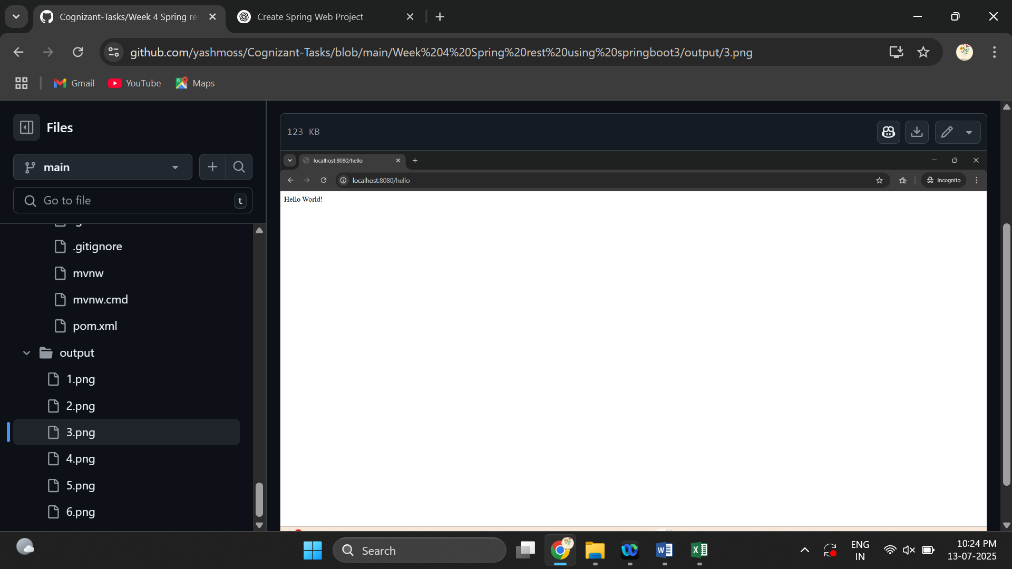

1. **REST - Country Web Service**

**CountryController.java**

package org.example.rest_country_web_service;

import org.example.rest_country_web_service.model.Country;

import org.springframework.context.ApplicationContext;

import org.springframework.context.support.ClassPathXmlApplicationContext;

import org.springframework.web.bind.annotation.GetMapping;

import org.springframework.web.bind.annotation.RequestMapping;

import org.springframework.web.bind.annotation.RestController;

@RestController

public class CountryController {

@GetMapping("/country")

public Country getcountry(){

ApplicationContext context= new ClassPathXmlApplicationContext("countrydefinition.xml");

return context.getBean("country",Country.class);

}

}

**RestCountryWebServiceApplication.java**

package org.example.rest_country_web_service;

import org.springframework.boot.SpringApplication;

import org.springframework.boot.autoconfigure.SpringBootApplication;

@SpringBootApplication

public class RestCountryWebServiceApplication {

public static void main(String[] args) {

SpringApplication.run(RestCountryWebServiceApplication.class, args);

}

}

Output:

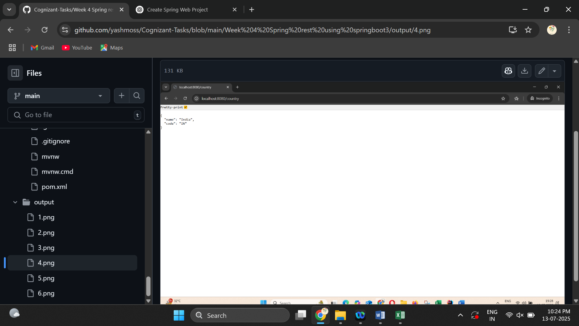

1. **REST - Get country based on country code**

package org.example.get_country_based_on_code.controller;

import org.example.get_country_based_on_code.model.Country;

import org.springframework.web.bind.annotation.GetMapping;

import org.springframework.web.bind.annotation.PathVariable;

import org.springframework.web.bind.annotation.RestController;

@RestController

public class CountryController {

@GetMapping("/country/{code}")

public Country getcountry(@PathVariable String code){

return Country.getCountry(code);

}

}

package org.example.get_country_based_on_code.model;

import java.util.ArrayList;

import java.util.List;

public class Country{

private String name;

private String code;

public Country(String name, String code) {

this.name = name;

this.code = code;

}

private static final List<Country> list= new ArrayList<>();

public static List<Country> getList(){

if(list.isEmpty()){

list.add(new Country("India","IN"));

list.add(new Country("NewZealand","NZ"));

list.add(new Country("England","ENG"));

list.add(new Country("Australia","AUS"));

}

return list;

}

public static Country getCountry(String code){

for(Country c:getList()){

if(c.getCode().equalsIgnoreCase(code)){

return c;

}

}

return null;

}

public String getName() {

return name;

}

public void setName(String name) {

this.name = name;

}

public String getCode() {

return code;

}

public void setCode(String code) {

this.code = code;

}

}

**GetCountryBasedOnCodeApplication.java**

package org.example.get_country_based_on_code;

import org.springframework.boot.SpringApplication;

import org.springframework.boot.autoconfigure.SpringBootApplication;

@SpringBootApplication

public class GetCountryBasedOnCodeApplication {

public static void main(String[] args) {

SpringApplication.run(GetCountryBasedOnCodeApplication.class, args);

}

}

Output:

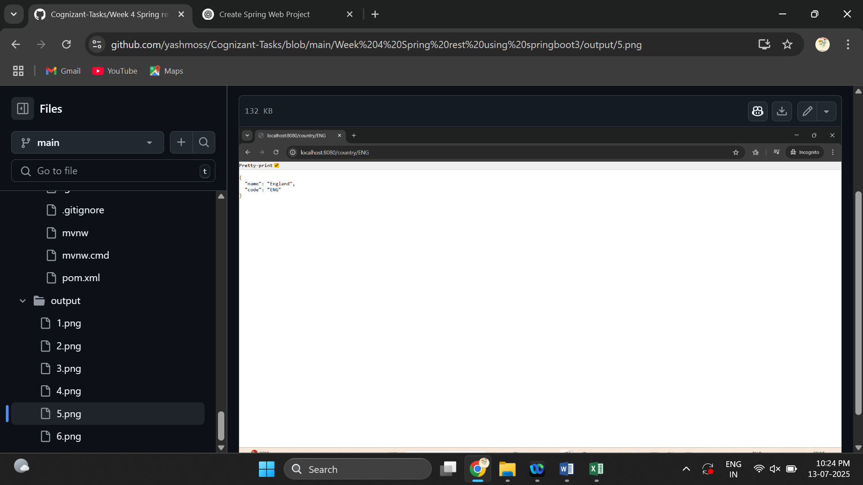

1. **Create authentication service that returns JWT**

package org.example.jwt;

import org.example.jwt.Jwtutil;

import org.springframework.http.ResponseEntity;

import org.springframework.web.bind.annotation.*;

import java.util.Base64;

@RestController

public class Authcontroller {

@GetMapping("/authenticate")

public ResponseEntity<?> authenticate(@RequestHeader("Authorization") String authHeader) {

String base64Credentials = authHeader.substring("Basic ".length());

String credentials = new String(Base64.getDecoder().decode(base64Credentials));

String[] values = credentials.split(":", 2);

String username = values[0];

String password = values[1];

// Dummy check

if (username.equals("user") && password.equals("pwd")) {

String token = Jwtutil.generateToken(username);

return ResponseEntity.ok().body("{\"token\":\"" + token + "\"}");

} else {

return ResponseEntity.status(401).body("Invalid credentials");

}

}

}

package org.example.jwt;

import org.springframework.boot.SpringApplication;

import org.springframework.boot.autoconfigure.SpringBootApplication;

@SpringBootApplication

public class JwtApplication {

public static void main(String[] args) {

SpringApplication.run(JwtApplication.class, args);

}

}

package org.example.jwt;

import io.jsonwebtoken.Jwts;

import io.jsonwebtoken.SignatureAlgorithm;

import io.jsonwebtoken.security.Keys;

import java.security.Key;

import java.util.Date;

public class Jwtutil {

private static final Key key = Keys.secretKeyFor(SignatureAlgorithm.HS256);

public static String generateToken(String username) {

return Jwts.builder()

.setSubject(username)

.setIssuedAt(new Date())

.setExpiration(new Date(System.currentTimeMillis() + 600000))

.signWith(key)

.compact();

}

}

import org.springframework.web.bind.annotation.GetMapping;

import org.springframework.web.bind.annotation.RestController;

@RestController

public class TestController {

@GetMapping("/test")

public String test() {

return "Server working";

}

}

Output:

